Synergy vs Zero Sum Dynamics Part II --Buffalo Can Be Bigger and Better, Not Just Bigger

By George Besch and Allison Leet December 6, 2019

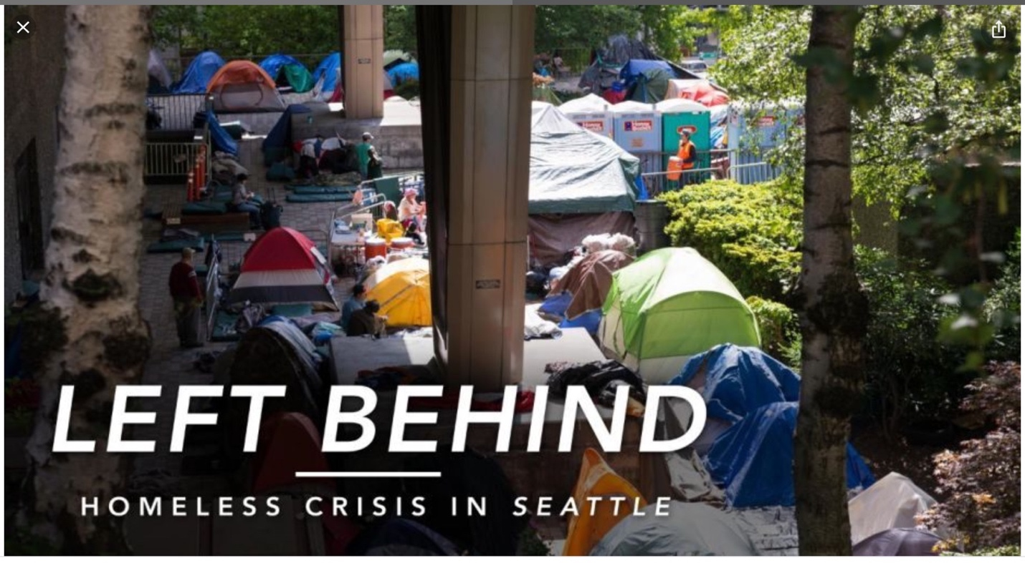Source: Fox News
In September I wrote about what synergy could achieve, and what the alternative, zero sum thinking, leads to. We face those alternatives right now. We have the potential of becoming one of the most livable, sustainable, and socially-just cities in the world, if we choose to develop the synergy, and plan our built environment and social infrastructure accordingly. That doesn’t come automatically just because there are a lot of good people and organizations involved in that planning. We will succeed and prosper with collaboration.

Many cities set a course to becoming sustainable. Seattle, for example, put the spotlight on themselves with the “Sustainable Seattle” slogan in 1991. I was teaching at Western Washington University’s Huxley College of Environmental Studies observing and participating in symposiums regarding the planning for Seattle’s sustainable strategic planning movement. Why is Seattle, despite great people, still struggling to become a model of sustainability? Sadly, because there was not enough authentic consideration of all community stakeholders. There was no understanding of the need to plan for the influx of monetary investment and people that would choose to move there, the social aspect of climate change we are referring to.

Acknowledging the importance of the blighted urban properties and Greater Buffalo-Niagara rural areas that are important to Buffalo’s viability, as well as the aforementioned social priorities, is a feature of what Designing to Live Sustainably is aiming to achieve when adapting to climate change here.
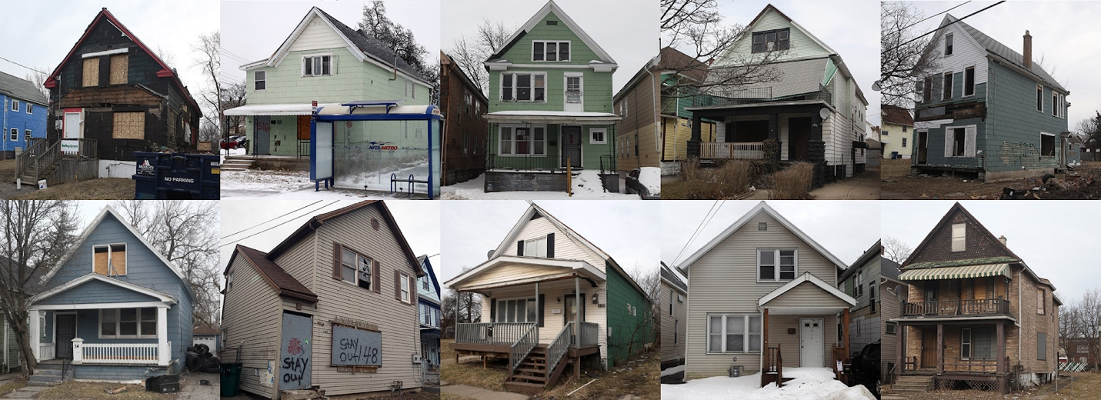
Source: The Buffalo News, “How a Kuwaiti's Ponzi scheme left a trail of blight in Buffalo” (April 28th, 2019)

The movement to Seattle may not have been driven by reactions to climate change, but the results of not being able to produce the planning responses to the movement are the same as what will happen to Buffalo if we don’t get to work. Clearly, the changes we are witnessing in Buffalo right now are also not primarily driven by our Weathering Change in WNY findings that it is a refuge from the effects of climate change. Seattle attracted big time investment, mostly in the form of high-tech companies, which resulted in many high paying jobs for some, driving the demand for housing to where it is unaffordable to many of the lower paying positions in those companies and a large demographic of now displaced residents.

The changes in Buffalo are already creating displacement issues, and the full impact of movement here from its climate refugee status will exacerbate the situation if not accounted for. We certainly have the space and the insight to avoid displacing the less fortunate if we stick to embracing the importance of social equity. Investment could improve the issues of inequality and displacement if we, the great organizations, governmental agencies and politicians in Buffalo, get out of our silos and work on collaborating on similar goals and supporting each other to do what we can to help people -- “Those already here and those who will be moving here.” People and investment will move here whether we like it, or want it, or prepare for it. We can avoid, or greatly reduce, the issues that plague Seattle and other overbuilt cities if we prepare for growth. Buffalo will get bigger. It would be better to be bigger and better not just bigger.

Another note to take away from Seattle is the pertinence of adequate public transportation and how we might plan to serve those who move into the neighborhoods where property is inexpensive-- for now. Seattle still suffers from not planning for light rail or tram transportation to locations outside of the city to focus the mixed-use development that would take place outside of the city, which resulted in building everywhere, sprawl that could then not easily be retrofitted with public transportation. It is not too late to start on light rail and tram public transportation within the city, not ignoring areas that are likely to see the most new development because of available building sites. It is not too late to start planning and building light rail public transportation to best suited points outside of the city to encourage higher density development there and curtail general sprawl.

Designing to Live Sustainably, via its Weathering Change in WNY initiative, intends to provide a mapping tool that will be useful to all of the organizations and agencies working on climate change action. It will apply to both the direct effects on our infrastructure and resources, and the movement of investment and people. To prepare for the effects of climate change, knowing more about those effects than those available from the large-scale NOAA modeling will be a significant asset. The trends analysis completed by Weathering Change in WNY indicates the effects WNY will experience differ substantially from what NOAA projects for its Northeast Region. And, we have identified 5 Climate Zones within the region whose effects will differ even further.

The trends analysis was the first step, a precursor, to a regional and metropolitan down-scaling of existing climate prediction models. This high-resolution modeling will be coupled with Geographic Information System (GIS) mapping overlays of geology, soils, water resources, land use, and public health. To improve upon the use of this tool, we are planning a series of stakeholder’s meetings where all parties are invited, citizen to government to businesses to non-profit and NGO’s to participate in brainstorming local WNY climate change aspects already being seen and what they would like to see come from the GIS strategic planning. Knowing what to expect in our WNY climate, coupled with GIS data and community input, will help us prepare for the direct physical and social effects which will impact us. Our goal is to further understand how the data will apply to what the stakeholders are doing, how we can improve on the initiative and involve everyone in it. A follow up to this article will go into detail regarding the Weathering Change in WNY Initiative and what GIS specifically can do for the WNY region’s strategic climate adaptation planning and how the use of data will make us thrive, not just survive, in the face of climate change.

Looking at Buffalo and WNY is like looking at the pieces of a jigsaw puzzle. We have a myriad of organizations which are one piece of the picture of a sustainable Buffalo that could thrive and provide refuge in the time of climate change. The number of pieces is growing as immigrants and investments arrive. Each piece looks different, maybe odd, and it isn’t apparent where they will fit to help complete the picture. But, given the opportunity, they will. We need each and every one of the pieces given a place in the puzzle in order to see the whole picture, to adapt and thrive, and become a sustainable city and region.

