Synergy vs Zero Sum Dynamics in Response to Global Warming and the Effects of Climate Change
by George Besch September 22, 2019
Synergy is the creation of a whole that is greater than the sum of its parts. In contrast, Zero Sum thinking believes that whatever is gained by one side is lost by the other. The first encourages cooperation and collaboration, while the second encourages competition.
While many scientists were warning of global warming much earlier, revelations about it began appearing at least as early as 1953 in publications such as Time Magazine (The Invisible Blanket); the NY Times (How Industry May Change the Climate); and in 1958, in a film by Frank Capra for Bell Labs (Unchained Goddess). However, rather than respond appropriately, zero sum thinking has kept the planet, its politicians, corporations and businesses, and ordinary citizens from doing anything meaningful to prevent its growing menace and threat to life on earth as they worry about what they might lose to others if they take steps to combat his global crisis. Since coining the phrase climate change, to dubious effect, there has been no significant change from zero sum thinking to synergistic action regarding mitigation of global warming, nor preparation for the effects which are already a cascading reality.
Buffalo and WNY will be a relative oasis from the direct effects of climate change.
Since 2009 Designing to Live Sustainably (D2LS) has been championing the reality that Buffalo and WNY will be a relative oasis from the direct effects of climate change, leading to its being a refuge for people seeking a viable place to relocate in the face of the catastrophic effects of climate related weather events being experienced across the US and globally. A place where not only people but financial investment will move.
When international investors ask me where they should put their money in the face of climate change, I say, Buffalo.
In 2017 D2LS began its collaboration with Dr. Stephen Vermette and BSC’s Department of Geography & Planning with Weathering Change in WNY. TJ Pignataro’s article about our work in the BN (October 24,2017) was noticed by Harvard professor Jesse Keenan, and in the Guardian (September 24,2018) he said, “When international investors ask me where they should put their money in the face of climate change, I say, Buffalo.” This leads to the NY Times (April 15, 2019) interviewing us about what was becoming an obvious consensus: Buffalo and WNY will be a climate refuge, people and investment will move here.
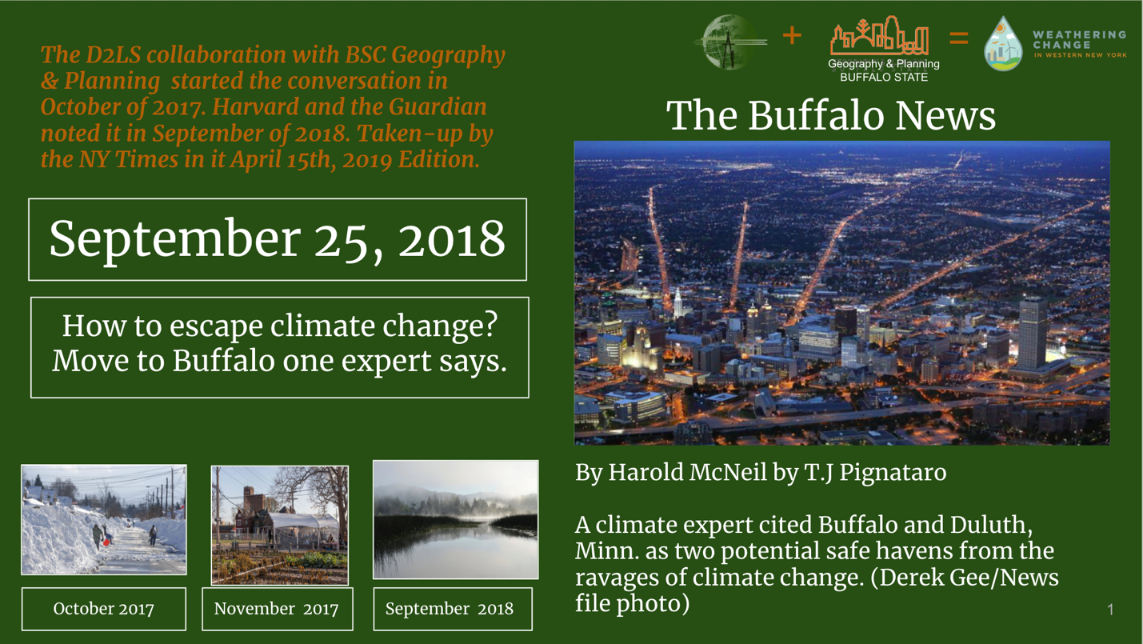
While not unique to Buffalo and WNY, the response to this clear and present opportunity to work together, to apply synergy to preparing for the less serious direct effects than elsewhere, is so far dominated by zero sum dynamics that encourages competition among groups. Buffalo and WNY have wonderful, advantageous “parts”: its natural resources, its location in the face of the the more frequent and sever effects of climate change impacting elsewhere, and its plethora of NGO organizations, governmental agencies and passionate, informed individuals who could respond with synergy to the opportunity to prepare for the direct effects as well as the arrival of climate refugees, climate migrants, and investment.
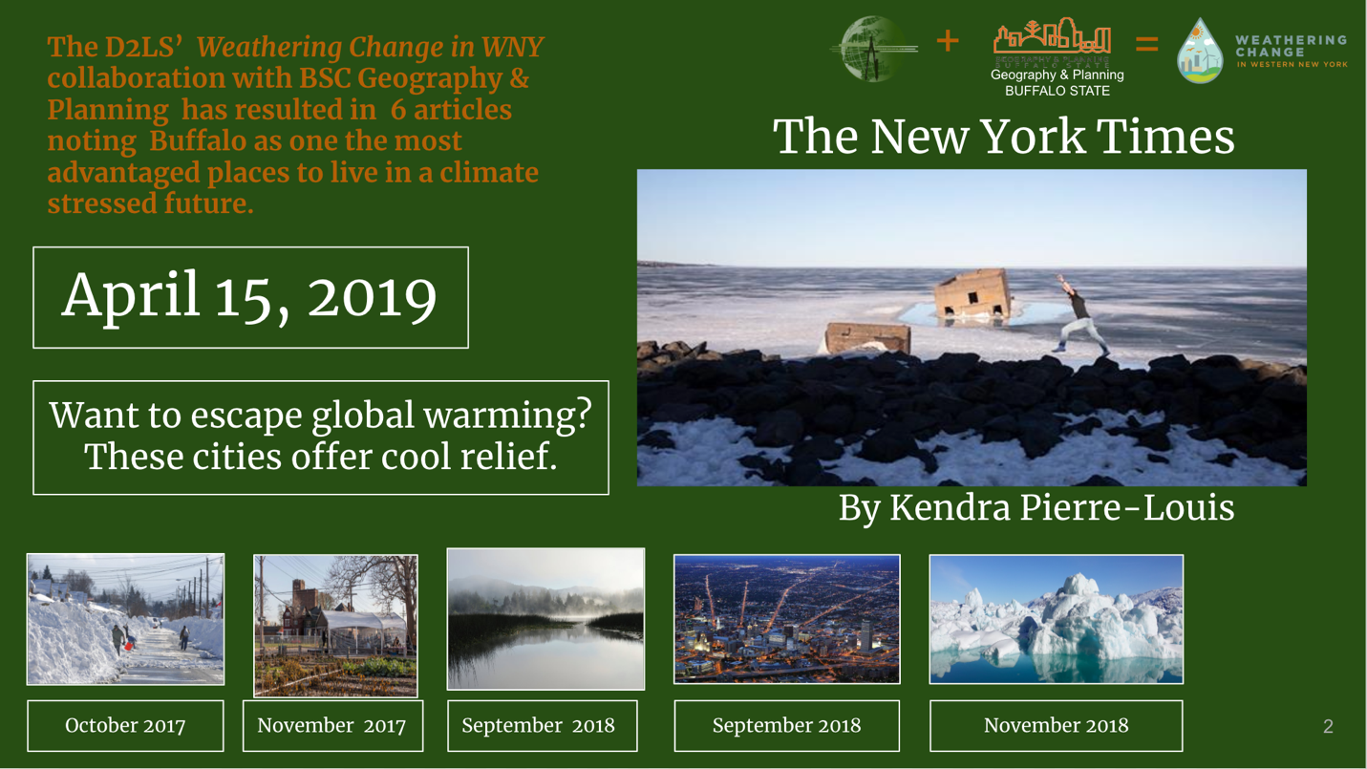
Overcoming zero sum dynamics and competition between groups, with synergy and collaboration instead, is important for more than just the physical benefits. Our responsibility to future generations demands we do more than merely cope with the effects of climate change. Designing our built environment and policies to facilitate doing well is important, but no amount or degree of only physical preparedness will be enough when the impacts from climate change create the most stress. Not only could the stress affect the people already living here, but there will be increasing numbers of climate refugees arriving having already experienced a great deal of stress. Investment could lead to climate gentrification if comprehensive and collaborative strategic planning efforts don’t lead to making it certain that environmental and social justice are included. Investment could lead to our natural resources, built environment, and everybody living here or moving here being better off than if we just continue in the zero sum mode.
Let’s cooperate and collaborate and realize the benefits of synergy.
Buffalo and WNY have an exceptional potential to survive, thrive and become one of the most livable cities and regions in the country. This will require upgrading our societal infrastructure too. If we don’t build on our humanity and caring ways of sharing and helping each other, we’ll experience the chaos likely to be the case if we don’t act according to our highest principles. Let’s love one another—the people already here and those we will welcome; let’s cooperate and collaborate and realize the benefits of synergy.
Lead image: Photo by William Bossen
Tagged with: Designing to Live Sustainably, Dr. Stephen Vermette, Synergy, TJ Pignataro, Weathering Change in WNY, Zero Sum
, , , , , ,

Written by George Besch
George Besch holds degrees in Ecology and Natural Resources Planning, served as a Peace Corps Volunteer in Guatemala, was a Fulbright Scholar to the Royal Academy of Fine Art in Denmark, and the Acting Head of the Department of Appropriate Technology and Human Ecology at Western Washington University. His work includes a Statewide Plan for Illinois, Regional plans in PA, CO, and NM, and site plans or feasibility studies in the UK, France, Austria, India, and Australia. These projects included climatological aspects and lead to his noting that WNY has not only comparative advantages in its natural resources, but in its being exceptionally well-positioned as the effects of climate change impact elsewhere more frequently and severely, prompting him to return to WNY and start Designing to Live Sustainably. After initially publishing and speaking of these advantages, including the expectation of climate migrants, a collaboration with Stephen Vermette at BSC’s Department of Geography and Planning began the process of documenting WNY climate’s differentiation as a precursor to more elaborate downscale modeling.

